**International Journal of Computer Sciences and Engineering Open Access**

**Review Paper Volume-5, Special Issue-1, Jun 2017 E-ISSN: 2347-2693**

**Design and Implementation of Solar Tracking**

A.S. Sawant1, P.M. Tambavekar2, P.D. Kokate3*, S.S. Vichare4, J. Satheesh5

1Dept. of Electrical Engineering, AC Patil College of Engineering (Mumbai University), Navi Mumbai, India

2Dept. of Electrical Engineering, AC Patil College of Engineering (Mumbai University), Navi Mumbai, India

3Dept. of Electrical Engineering, AC Patil College of Engineering (Mumbai University), Navi Mumbai, India

4Dept. of Electrical Engineering, AC Patil College of Engineering (Mumbai University), Navi Mumbai, India

5Dept. of Electrical Engineering, AC Patil College of Engineering (Mumbai University), Navi Mumbai, India

*\*Corresponding Author:* [*prasadtambavekar@gmail.com*](mailto:prasadtambavekar@gmail.com)*, Mob.: 9028970816*

**Available online at: www.ijcseonline.org**

***Abstract***: - Energy crisis is the most important issue in today’s world. Conventional energy resources are not only limited but also cause environmental pollution. Renewable energy resources are getting priorities in the whole world to lessen the dependency on conventional resources. Solar energy is rapidly gaining the focus as an important means of expanding renewable energy uses. Solar cells those convert sun’s energy into electrical energy are costly and inefficient. Different mechanisms are applied to increase the efficiency of the solar cell to reduce the cost. Solar tracking system is the most appropriate technology to enhance the efficiency of the solar cells by tracking the sun. A microcontroller based design methodology of an automatic solar tracker is presented in this paper. Light dependent resistors are used as the sensors of the solar tracker. A small prototype of solar tracking system is also constructed to implement the design methodology presented here.

***Keywords***: - Solar Energy, Solar Tracking, H-Bridge, Solar Power System.

1. **INTRODUCTION**

As of 31 July 2016, the country's solar gird has a cumulative capacity of 8,062 MW (8GW) [1]. The daily average solar energy incident over India varies from 4 to 7 kWh/m2 with about 1500–2000 sunshine hours per year (depending upon location), which is far more than current total energy consumption. For example, assuming the efficiency of PV modules as low as 10%, this would still be a 12 thousand times greater than the domestic electricity demand projected for 2015.

The aim of the project is to keep the solar photovoltaic panel perpendicular to the sun throughout the year in order to make it more efficient. The dual axis solar photovoltaic panel takes astronomical data as reference and the tracking system has the capability to always point the solar array toward the sun and can be installed in various regions with minor modifications. The vertical and horizontal motion of the panel is obtained by taking altitude angle and azimuth angle as reference. The fuzzy controller has been used to control the position of DC motors. The mathematical simulation control of dual axis solar tracking system ensures the point to point motion of the DC motors while tracking the sun. Fig. 1 shows the average solar radiations receiver by different regions in India.

This paper describes the solar tracking system. Section I gives the Introduction of Solar Radiation and Conventional tracking System. Section II introduces us to Solar Tracker System and its types. Section III shows us System design and Algorithm for Functioning. Section IV would show observation and result. Paper is concluded and idea for Future Scope is given in Section 5.

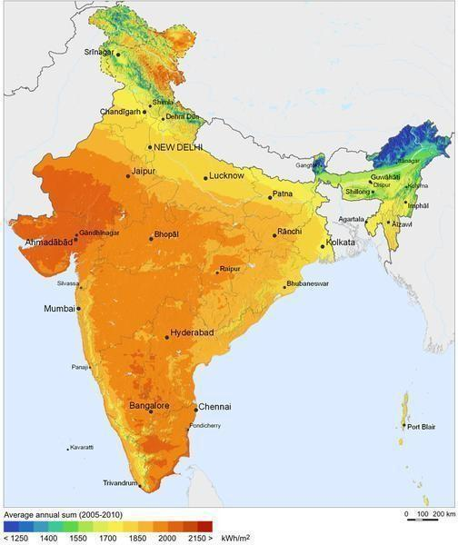

*Figure 1: The average solar radiations receiver by different regions in India [1]*.

1. **SOLAR TRACKER**

Solar Tracker is a device which follows the movement of the sun as it rotates from the east to the west every day. The main function of all tracking systems is to provide one or two degrees of freedom in movement. Trackers are used to keep solar collectors/solar panels oriented directly towards the sun as it moves through the sky every day. Using solar trackers increases the amount of solar energy which is received by the solar energy collector and improves the energy output of the heat/electricity which is generated. Solar trackers can increase the output of solar panels by 20-30% which improves the economics of the solar panel project. [2]

1. ***SINGLE AXIS SOLAR TRACKER***

The single Axis Solar Tracking System realizes the movement of either elevation or azimuth for a solar power system. Which one of these movements is desired, depends on the technology used on the tracker as well as the space that it is mounted on. A single-axis tracker can only pivot in one plane – either horizontally or vertically [3].This makes it less complicated and generally cheaper than a two axis tracker, but also less effective at harvesting the total solar energy available at a site. Trackers use motors and gear trains to direct the tracker as commanded by a controller responding to the solar direction. Since the motors consume energy, one wants to use them only as necessary. Active trackers, which use motors and gear trains, are controlled by an electronic circuit responding to the solar direction. Increasing the cell efficiency, maximizing the power output and employing a tracking system with solar panel are three ways to increase the overall efficiency of the solar panel.

1. ***DUAL AXIS SOLAR TRACKER***

Dual axis trackers have two degrees of freedom that act as axes of rotation. These axes are typically normal to one another. Dual axis trackers allow for optimum solar energy levels due to their ability to follow the sun vertically and horizontally.

1. ***APPLICATIONS***

In this paper a solar tracker is realized to detect a maximum power from sunlight. The position of maximum detection power is stored in memory. The stored data can be applicable for many application such as Large photo voltaic panels can track the sun all the day light and by that give above 95% efficiency in generating electricity; solar heaters will also track the sun all the day light and by that less panels are required at the initial cost; while in the home automation systems, this system is also needed in turning light ON and Off and also for opening and closing the curtains.

1. **SYSTEM DESIGN AND ALGORITHM**

The purpose of a solar tracker is to accurately determine the position of the sun. This enables solar panels to interface to the tracker to obtain the maximum solar radiation. With this particular solar tracker a closed loop system is made. The electrical system consists of two LDR sensors which provide feedback to a microcontroller-bridge is used as Driver Circuit for DC motor. The Major Components used are:

1. Solar Panel
2. LDR Sensors
3. DC motor
4. H-Bridge
5. Arduino

The block diagram of Single Axis Solar Tracker is shown below:



*Figure 2:- Block Diagram of Single Axis Solar Tracker*

1. *SOLAR PANEL:*

A 12 volt, 5 watt panel is chosen under pure climatic conditions. The Solar Panel consists of Mono-Crystalline Solar Cells. The manufacturer is BLUE ENERGY Pvt. Ltd.

|  |  |
| --- | --- |
| Table 1:-Specification of Solar Panel |  |

|  |  |
| --- | --- |
| **Weight** | **800gm** |
| Dimension | 8*12 inch |
| Power Max(Pm) | 5 watt +/- 5% |
| Maximum Voltage(Vmp) | 17.00V |
| Short Circuit Current(Isc) | 0.47A |
| Max Power Current (Imp) | 0.30A |
| Open Circuit Voltage (Voc) | 21.00v |

1. *LDR Sensors:*

Four Light Dependent Resistors as Sensors. They sense the higher density area of sunlight. The solar panel moves to high light density area through DC Motors. Each LDR is connected to power supply forming a potential divider. Thus any change in light density is proportional to change in voltage across the LDR’s [4].

1. *DC Motor:*

Solar trackers rely on a direct-current (DC) motor Driver circuit to control the movement of the solar panel. However, conventional DC motor drivers used in solar tracking system do not provide any options for speed and torque control. Hence, the fixed speed of the DC motor leads to either too fast or too slow tracking movement.

An H-Bridge is used to control the direction of motor and to also provide enough current for motor to run. Adaptive controlling of the output voltage and current are possible by installing algorithm in the microcontroller of the DC motor driver and it can be reprogrammed according to the requirement. The speed control makes the solar tracking system to track the Sun more accurately and the torque control saves energy. The specifications of Dc motor are as follows:

Table 2:- Specification of DC Motor

|  |  |
| --- | --- |
| RPM | 10 RPM |
| Operating Voltage | 12volts |
| Shaft Diameter | 6mm |
| Weight | 125gm |
| Torque | 5kg-cm |
| No-Load Current | 60mA(Max) |
| Load Current | 300mA(Max) |

1. *H-Bridge:*

A D.C. Motor requires a voltage difference between its terminals to rotate. The direction in which a motor rotates in determined by which side of the motor is connected to the positive and negative terminals. Swapping the positive and negative terminals will cause the motor to rotate in the opposite direction. An H-Bridge is used to control the direction of the motor and to also provide enough current for the motor to run. H Bridge is a simply set of switches used to alter polarity on a permanent magnet motor thus changing the direction of rotation DESIGN CIRCUTRY:

The drive circuitry for an H-Bridge is basically the electronics that sits between the PWM (and potentially other) digital control inputs and the MOSFET gates. It has two major purposes:

1. Translate the input voltages to suitable levels to drive the gates
2. Provide enough current to charge and discharge the gates fast enough

There are low-side drivers that are designed to drive Q2 or Q4 in this bridge. High-side drivers in turn are designed to drive Q1 or Q3. Half-bridge drivers combine one low- and one high-side driver, so they can drive Q1 and Q2 (or Q3 and Q4) together. Full-bridge drivers obviously have two low-side and two high-side drivers so they can drive all four FETs. Low-side MOSFETs are always N-channel ones, while on the high-side we can use either P-channel or N-channel devices.

The components of H-bridge are decided on basis of Maximum current drawn by DC motor.

Also the main reason behind choosing MOSFET H-Bridge is Fast Switching Action of MOSFET.

The H-Bridge circuit for motor driving operation is shown below:

*Figure 3:- Circuit for H-Bridge*

1. *ARDUINO:*

The ATMEGA- 328 micro-controller is used in Arduino. The ADC input through computer is supplied and PWM output is obtained which drives the motor. LDR’s have two pins, and to get voltage value from it we use potential divider circuit. In potential divider we get Vout corresponding to resistance of LDR which in turn is a function of light falling on LDR. The higher the intensity of light, lower the LDR resistance and hence lower the Output voltage (Vout) And lower the light intensity, higher the LDR resistance and hence higher the Vout[5].

The algorithm required for Control of position of solar panels through Micro-Controller is given:

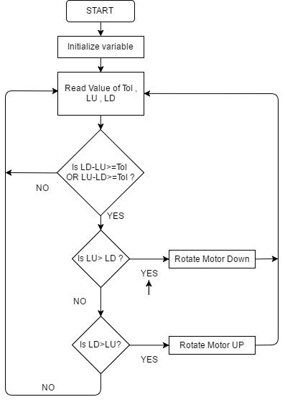

*Figure 4:- Algorithm for Single Axis solar tracker.*

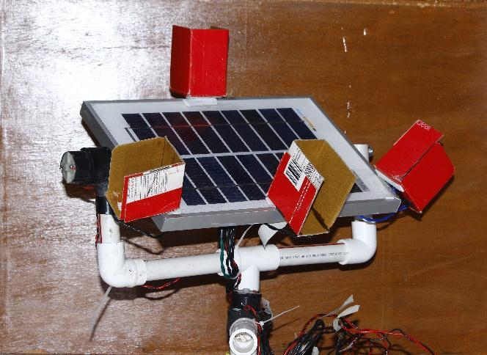

*Figure 5:- Solar Tracking System*

1. **OBSERVATION AND RESULT**

The readings for Single Axis Solar Tracker for a Single day from 7.00am to 1.00pm are taken in a fine sunny day. The current and voltage readings are taken for a regular time interval and maximum power is calculated. The following readings are tabulated and a graph for power versus time was generated as follows:

Table 3:- V-I readings of Single Axis Tracking system

|  |  |  |  |
| --- | --- | --- | --- |
| TIME | VOLTAGE(V) | CURRENT(A) | POWER(W) |
| 7.00am | 3.65 | 0.0016 | 0.00584 |
| 7.30am | 9.63 | 0.0316 | 0.3043 |
| 8.00am | 10.63 | 0.156 | 1.6583 |
| 8.30am | 10.78 | 0.27 | 2.9106 |
| 9.00am | 10.78 | 0.38 | 4.096 |
| 9.30am | 10.78 | 0.44 | 4.7432 |
| 10.00am | 10.72 | 0.45 | 4.824 |
| 10.30am | 10.74 | 0.44 | 4.726 |
| 11.00am | 10.76 | 0.45 | 4.842 |
| 11.30am | 10.78 | 0.46 | 4.959 |
| 12.00am | 10.78 | 0.46 | 4.959 |
| 12.30am | 10.78 | 0.45 | 4.851 |
| 01.00pm | 10.75 | 0.42 | 4.515 |

The graph showing time versus power is shown below:

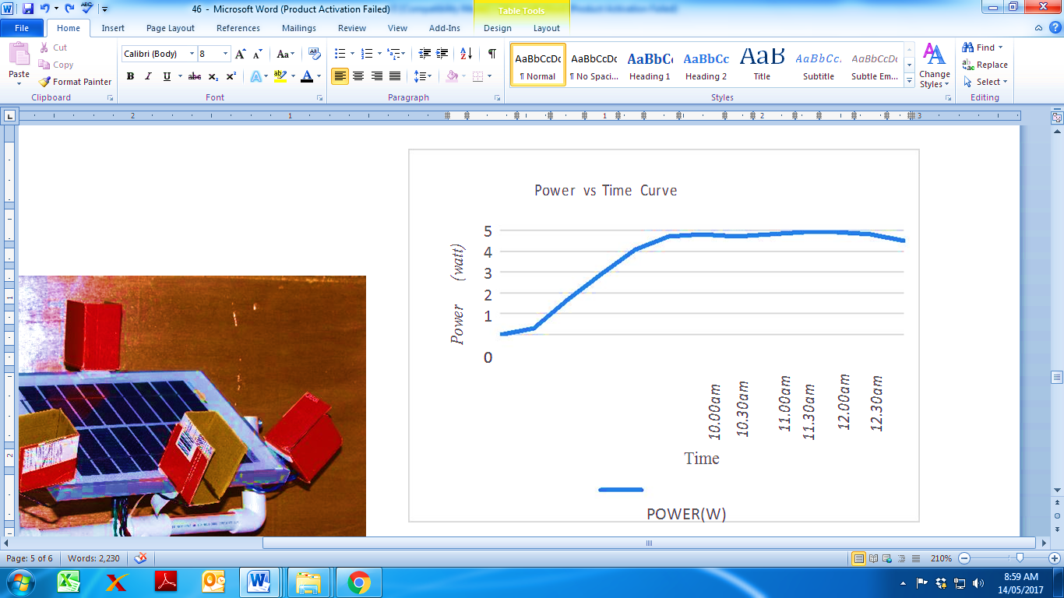

Fig 6:- Power vs. Time Curve for Single Axis Solar Tracker

1. **CONCLUSION**

This paper has presented an evaluation of single axis tracker system using H-bridge driver circuit. The design, analysis and working considerations are presented. The single axis tracking system tracks the solar radiations and efficiency increases as maximum power is captured in comparison with a conventional stand-alone solar tracking system. Dual Axis Solar Tracking System has more efficiency than Single Axis Solar tracking system. For Dual Axis Solar Tracking System same circuitry can be used with four LDRs connected at EAST, WEST, NORTH, and SOUTH. Also a separate algorithm would be required for Dual Axis Tracking System.

1. **REFERENCES**
2. Krishna N. Das (January 2, 2015). [*"India's Modi raises solar investment target to $100 bln by 2022"*](http://www.reuters.com/article/2015/01/02/india-solar-idUSL3N0UG13H20150102). Reuters. Retrieved 2015-01-02
3. A. Kassem, M. Hamad*,”A Microcontroller-Based Multi-Function Solar Tracking System”, IEEE 2011.*
4. Deepthi.S, Ponni.A, Ranjitha.R, R Dhanabal, *“Comparison of Efficiencies of Single-Axis Tracking System and Dual-Axis Tracking System with Fixed Mount”, International Journal of Engineering Science and Innovative Technology (IJESIT), Volume 2, Issue 2, March 2013.*
5. Diffenderfes, Robert (2005). Electronic Devices: System and Applications. New Delhi: Delimar. p. 480. *ISBN* *978-1401835149*.
6. *"Arduino - Introduction"*. arduino.cc.